Tribhuwan University
Institution Of Science & Technology

Lab Report Of Design and Analysis of Algorithms
Under The Supervision Of
Mr. Deepak Bhatta
Vedas College,
Jawalakhel, Lalitpur

SUBMITTED BY:

Basab Jha
Year III/Semester V
VC79IT02

SUBMITTED TO:
In the partial fulfillment of requirement of the degree of B.Sc. CSIT
Mr. Deepak Bhatta
Lecturer
Vedas College
Jawalakhel, Lalitpur

2024

Lab I
Basic Recursive & Iterative Algorithms

1. GCD (Greatest Common Divisor)

Code Implementation:
#include <stdio.h>
#include <time.h>

int gcd(int a, int b) {
while (b != 0) {
int temp = b;
b = a % b;
a = temp;
}
return a;
}

int main() {
int a, b;
printf("Enter two numbers to find their GCD: ");
scanf("%d %d", &a, &b);

clock_t start_declare_time = clock();

clock_t start_process_time = clock();

int result = gcd(a, b);

clock_t end_process_time = clock();

printf("\nGCD of %d and %d is: %d\n", a, b, result);

double declare_to_process_time = ((double)(start_process_time - start_declare_time)) / CLOCKS_PER_SEC * 1000;
double process_duration = ((double)(end_process_time - start_process_time)) / CLOCKS_PER_SEC * 1000;
double total_time = ((double)(end_process_time - start_declare_time)) / CLOCKS_PER_SEC * 1000;

printf("\nTime taken from declaration to process start: %.6f ms\n", declare_to_process_time);
printf("Time taken for the computation process: %.6f ms\n", process_duration);
printf("Total time taken: %.6f ms\n", total_time);

return 0;
}

Output
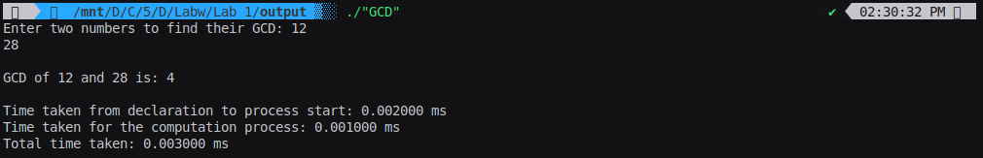
Time Complexity Analysis
- The Euclidean algorithm iteratively reduces the problem size by replacing (a, b) with (b, a % b).
- Worst-case scenario: This happens when the numbers are consecutive Fibonacci numbers. The number of iterations is proportional to log(min(a,b)).
- Time Complexity: O(log(min(a,b))).

Space Complexity Analysis
- The algorithm runs iteratively and uses only a constant amount of space for variables.
- Space Complexity: O(1) (constant space).

2.Factorial of a Number
Code
#include <stdio.h>
#include <time.h>

long long factorial_recursive(int n) {
if (n == 0 || n == 1)
return 1;
return n * factorial_recursive(n - 1);
}
int main() {
int num;
printf("Enter a number to calculate its factorial: ");
scanf("%d", &num);

if (num < 0) {
printf("Factorial of a negative number is undefined.\n");
return 1;
}

clock_t start_recursive = clock();
long long result_recursive = factorial_recursive(num);
clock_t end_recursive = clock();
double time_recursive = ((double)(end_recursive - start_recursive)) / CLOCKS_PER_SEC;

printf("\nFactorial of %d (Recursive): %lld\n", num, result_recursive);
printf("Time taken (Recursive): %f seconds\n", time_recursive);
return 0;
}

Output
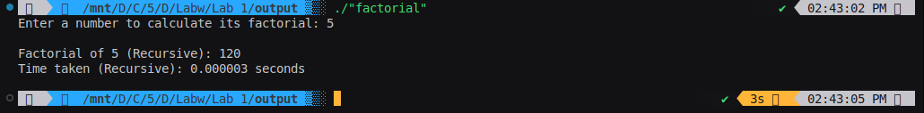

Time Complexity:
- The function makes n recursive calls, where n is the input number.
- Each call performs a constant amount of work (multiplication).
- Time Complexity: O(n).

Space Complexity:
- Each recursive call occupies space on the function call stack.
- In the worst case, n recursive calls are made before hitting the base case.
- Space Complexity: O(n) (stack memory grows linearly with n).

3. Fibonacci Number
#include <stdio.h>
#include <time.h>

long long fibonacci_recursive(int n) {
if (n <= 1)
return n;
return fibonacci_recursive(n - 1) + fibonacci_recursive(n - 2);
}

int main() {
int num;

printf("Enter the Fibonacci term to calculate: ");
scanf("%d", &num);

clock_t start_recursive = clock();
long long result_recursive = fibonacci_recursive(num);
clock_t end_recursive = clock();
double time_recursive = ((double)(end_recursive - start_recursive)) / CLOCKS_PER_SEC;

printf("\nFibonacci term %d (Recursive): %lld\n", num, result_recursive);
printf("Time taken (Recursive): %f seconds\n", time_recursive);

return 0;
}

Output
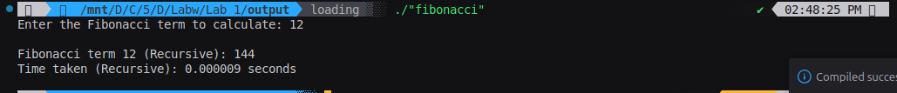

Time and Space Complexity

Recursive Method
- Time Complexity: O(2n)
  - Each call splits into two more calls, resulting in an exponential growth of calls.
- Space Complexity: O(n)
  - The call stack grows linearly with n as each recursive call waits for the result of the next call.

Lab II
Searching and Sorting Techniques

1. Bubble Sort
Code
#include <stdio.h>
#include <time.h>

void bubbleSort(int arr[], int n) {
for (int i = 0; i < n - 1; i++) {
for (int j = 0; j < n - i - 1; j++) {
if (arr[j] > arr[j + 1]) {
int temp = arr[j];
arr[j] = arr[j + 1];
arr[j + 1] = temp;
}
}
}
}

int main() {
int n;

printf("Enter the number of elements: ");
scanf("%d", &n);

int arr[n];
printf("Enter %d elements: ", n);
for (int i = 0; i < n; i++) {
scanf("%d", &arr[i]);
}

clock_t start = clock();
printf("Start time: %ld\n", start);

bubbleSort(arr, n);
clock_t end = clock();
printf("End time: %ld\n", end);
double time_taken = ((double)(end - start)) / CLOCKS_PER_SEC;
printf("Sorted array: ");
for (int i = 0; i < n; i++) {
printf("%d ", arr[i]);
}
printf("\nTime taken: %f seconds\n", time_taken);

return 0;
}

Output
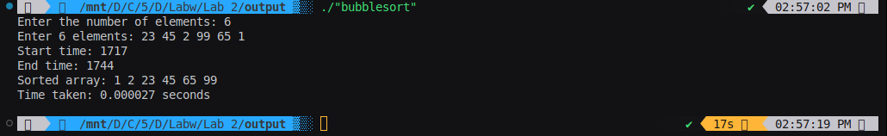

Time Complexity
- Best Case: O(n)
  - When the array is already sorted, a single pass confirms no swaps are required.
- Worst Case: O(n2)
  - When the array is sorted in reverse order, the algorithm performs the maximum number of comparisons and swaps.
- Average Case: O(n2)

Space Complexity
- Space Complexity: O(1)
  - Sorting is done in-place without using additional memory.

2.Selection Sort
Code
#include <stdio.h>
#include <time.h>

void selectionSort(int arr[], int n) {
for (int i = 0; i < n - 1; i++) {
int minIndex = i;
for (int j = i + 1; j < n; j++) {
if (arr[j] < arr[minIndex]) {
minIndex = j;
}
}
int temp = arr[minIndex];
arr[minIndex] = arr[i];
arr[i] = temp;
}
}

int main() {
int n;

printf("Enter the number of elements: ");
scanf("%d", &n);

int arr[n];
printf("Enter %d elements: ", n);
for (int i = 0; i < n; i++) {
scanf("%d", &arr[i]);
}

clock_t start = clock();
printf("Start time: %ld\n", start);

selectionSort(arr, n);

clock_t end = clock();
printf("End time: %ld\n", end);

double time_taken = ((double)(end - start)) / CLOCKS_PER_SEC;

printf("Sorted array: ");
for (int i = 0; i < n; i++) {
printf("%d ", arr[i]);
}
printf("\nTime taken: %f seconds\n", time_taken);

return 0;
}

Output
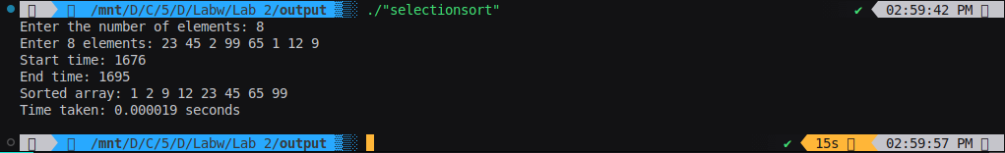
Time Complexity
- Best Case: O(n2)
  - Regardless of the input, the algorithm always performs n(n−1)/2 comparisons.
- Worst Case: O(n2)
  - Even if the array is sorted in reverse order, the algorithm still performs n(n−1)/2 comparisons.
- Average Case: O(n2)

Space Complexity
- Space Complexity: O(1)
  - Sorting is done in-place without additional memory usage.

3.Insertion Sort
Code
#include <stdio.h>
#include <time.h>

void insertionSort(int arr[], int n) {
for (int i = 1; i < n; i++) {
int key = arr[i];
int j = i - 1;
while (j >= 0 && arr[j] > key) {
arr[j + 1] = arr[j];
j--;
}
arr[j + 1] = key;
}
}

int main() {
int n;

printf("Enter the number of elements: ");
scanf("%d", &n);

int arr[n];
printf("Enter %d elements: ", n);
for (int i = 0; i < n; i++) {
scanf("%d", &arr[i]);
}

clock_t start = clock();
printf("Start time: %ld\n", start);

insertionSort(arr, n);

clock_t end = clock();
printf("End time: %ld\n", end);

double time_taken = ((double)(end - start)) / CLOCKS_PER_SEC;

printf("Sorted array: ");
for (int i = 0; i < n; i++) {
printf("%d ", arr[i]);
}
printf("\nTime taken: %f seconds\n", time_taken);

return 0;
}

Output
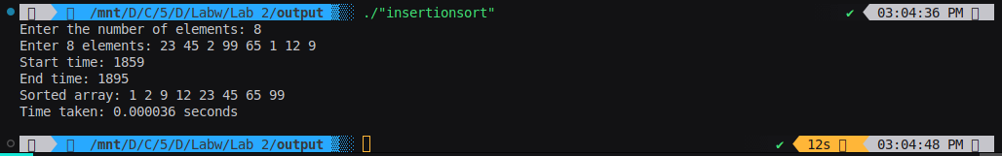

Time Complexity
- Best Case: O(n)
  - When the array is already sorted, only one comparison is made per element.
- Worst Case: O(n2)
  - When the array is sorted in reverse order, every element has to be compared with all preceding elements and shifted.
- Average Case: O(n2)

Space Complexity
- Space Complexity: O(1)
  - Sorting is done in-place without additional memory usage.

4.Sequential search
Code
#include <stdio.h>
#include <time.h>

void sequentialSearch(int arr[], int n, int target) {
for (int i = 0; i < n; i++) {
if (arr[i] == target) {
printf("Element found at index %d\n", i);
return;
}
}
printf("Element not found\n");
}

int main() {
int n, target;

printf("Enter the number of elements: ");
scanf("%d", &n);

int arr[n];
printf("Enter %d elements: ", n);
for (int i = 0; i < n; i++) {
scanf("%d", &arr[i]);
}

printf("Enter the target element to search: ");
scanf("%d", &target);

clock_t start = clock();
printf("Start time: %ld\n", start);

sequentialSearch(arr, n, target);

clock_t end = clock();
printf("End time: %ld\n", end);

double time_taken = ((double)(end - start)) / CLOCKS_PER_SEC;
printf("Time taken: %f seconds\n", time_taken);

return 0;
}

Output
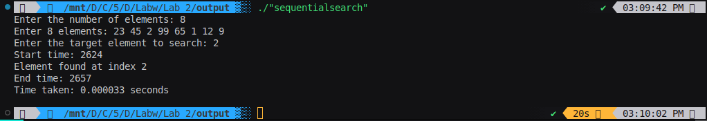

Time Complexity:
- Initialization: Initializing the array takes O(n) time, where n is the number of elements.
- Search Operation: The sequential search in the worst case requires checking all n elements, so it has a time complexity of O(n).
- Overall Time Complexity: O(n)

Space Complexity:
- The space complexity is O(n), as the array of n elements is stored in memory.

